ML Microservices Platform
using FastAPI, Docker, Kubernetes, and Monitoring

1. Introduction
This project presents a complete Machine Learning microservices platform designed using modern backend and DevOps practices. The system enables users to authenticate, perform predictions using a trained ML model, and store/retrieve prediction history. The architecture follows a microservices approach and is deployed using Docker and Kubernetes.

2. Objectives
- Build a scalable ML-based backend system
- Implement microservices architecture
- Integrate authentication using JWT
- Deploy services using Docker and Kubernetes
- Provide a simple frontend interface
- Implement basic monitoring using Prometheus and Grafana

3. System Architecture
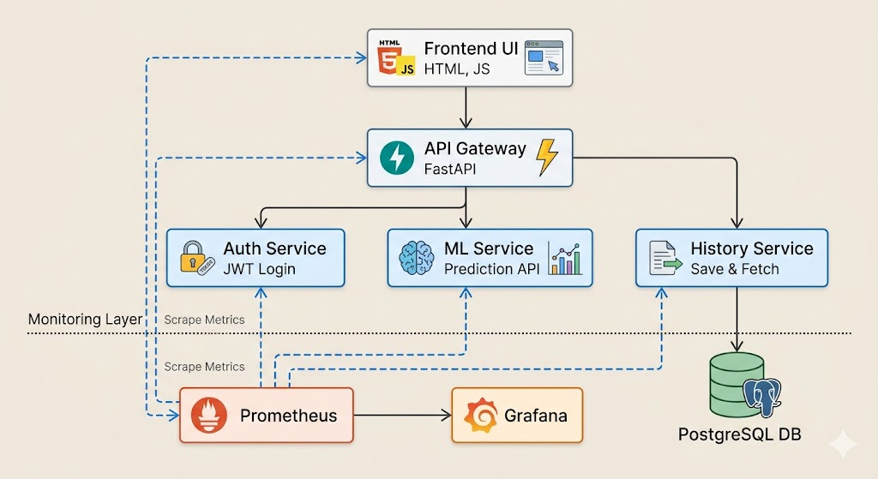
The system consists of multiple independent services:
🔹 API Gateway
- Central entry point for all client requests
- Handles routing between services
- Performs authentication verification
🔹 Auth Service
- Handles user registration and login
- Generates JWT tokens for secure access
🔹 ML Service
- Loads trained machine learning model
- Provides prediction results based on input data
🔹 History Service
- Stores prediction results in PostgreSQL
- Retrieves past predictions
🔹 Database (PostgreSQL)
- Stores prediction records
🔹 Frontend
- Simple HTML, CSS, JavaScript interface
- Allows login, prediction, and viewing history

4. Technologies Used
Category | Technology
Backend | FastAPI (Python)
ML Model | Scikit-learn
Database | PostgreSQL
Containerization | Docker
Orchestration | Kubernetes (Minikube)
Monitoring | Prometheus, Grafana
Frontend | HTML, CSS, JavaScript

5. Features Implemented
✅ Authentication
- JWT-based login system
- Secure API access using tokens
✅ Prediction System
- Input: gender, age, salary
- Output: prediction + meaning
✅ Data Storage
- Predictions saved in PostgreSQL
- History retrieval supported
✅ API Gateway
- Centralized request handling
- Inter-service communication
✅ Frontend UI
- User-friendly interface
- Real-time prediction and history display
✅ Containerization
- Each service containerized using Docker
- Images pushed to Docker Hub
✅ Kubernetes Deployment
- Services deployed using Deployments and Services
- Internal service communication using ClusterIP
- External access via NodePort and port-forward
✅ Monitoring (Basic)
- Prometheus collects service metrics
- Grafana visualizes system status

6. Workflow
- User logs in via frontend
- Auth service validates credentials and returns JWT
- User sends prediction request via API Gateway
- Gateway forwards request to ML service
- ML service returns prediction
- Gateway sends data to History service
- History service stores data in PostgreSQL
- User can view prediction history via frontend

7. Challenges Faced
- Handling inter-service communication in Kubernetes
- Debugging port-forward and service exposure issues
- Fixing CORS errors between frontend and backend
- Ensuring correct data format between services
- Managing Docker image versions and deployments

8. Results
- Successfully built a working ML microservices platform
- Achieved seamless integration between services
- Enabled real-time predictions and data persistence
- Implemented monitoring for system visibility

9. Conclusion
This project demonstrates the practical implementation of microservices architecture combined with machine learning deployment. It highlights real-world concepts such as containerization, orchestration, API communication, and monitoring. The system is scalable, modular, and aligns with industry practices.

10. Future Enhancements
- Add advanced metrics (latency, request tracking)
- Implement role-based authentication
- Improve frontend using modern frameworks (React)
- Deploy on cloud platforms (AWS/GCP)
- Add CI/CD pipeline

Final Outcome
A fully functional ML microservices platform with authentication, prediction, history tracking, containerization, orchestration, and monitoring.

